4.56: a) The equation of motion, 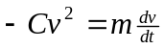 cannot be integrated with respect to time, as the unknown function 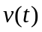 is part of the integrand. The equation must be separated before integration; that is,
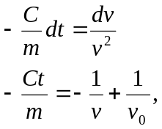
where  is the constant of integration that gives 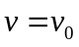 at . Note that this form shows that if 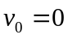, there is no motion. This expression may be rewritten as
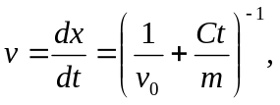
which may be integrated to obtain
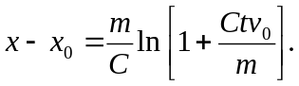
To obtain x as a function of v, the time t must be eliminated in favor of v; from the expression obtained after the first integration, 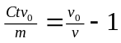, so
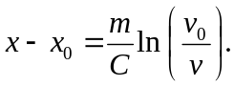
b) By the chain rule,
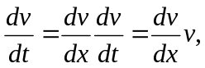
and using the given expression for the net force,

